CSV 304 ASSIGNMENT 1

Name: K.Punith Sai

Reg.No: 12115191

Section: K21XR

Roll No: K21XRA22

Part 1: Installing Jenkins on VM and building job with github integration.

* Login to AWS console and navigate to EC2 , launch an instance and name it as “Jenkins”. Select the os as ‘Ubuntu’ and choose the instance type as ‘t2.medium’. Create a keypair and select the memory of the instance.

View the instance status and copy the ip address of the instance.

Use any ssh connector like MobaXterm and connect the instance through ip address.

After successfully connecting the instance , go to root by “sudo su” command.

Update the packages by “apt update” command.

Install java by the command “ apt install openjdk-17-jre”.

Check the java version by “java –version” command.

Now, Install the Jenkins by following commands.

After successful installation of Jenkins , check the status of Jenkins by the command “systemctl status Jenkins” .

Now go to AWS EC2 dashboard and configure the port “8080” to Jenkins.

By <http://Ipaddress:8080> , we can access Jenkins page. Copy the admin password and paste it on the login page of Jenkins.

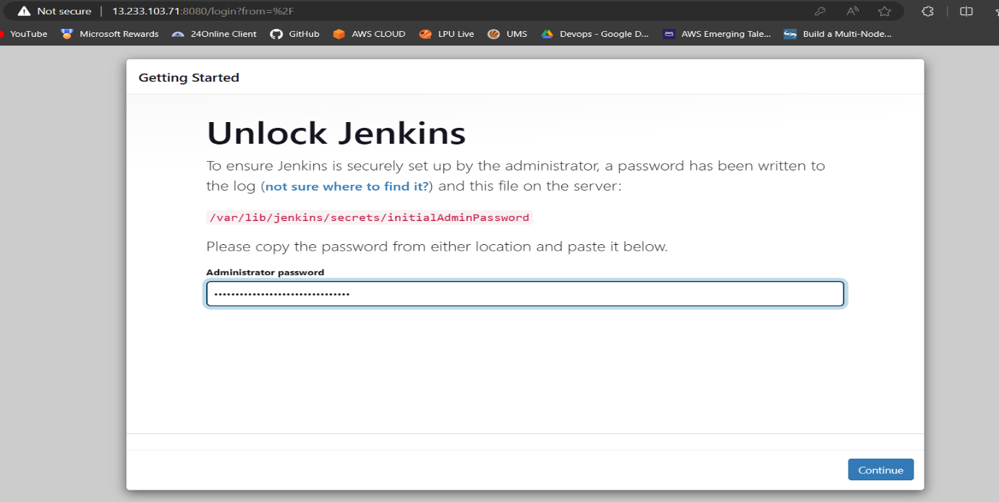

After installing the plugins , Jenkins dashboard gets displayed.

Create first job in Jenkins. Name the job and select ‘Freestyle project’.

Enter the github url of which we want to build an job.

After entering the details correctly , click on build now to build.

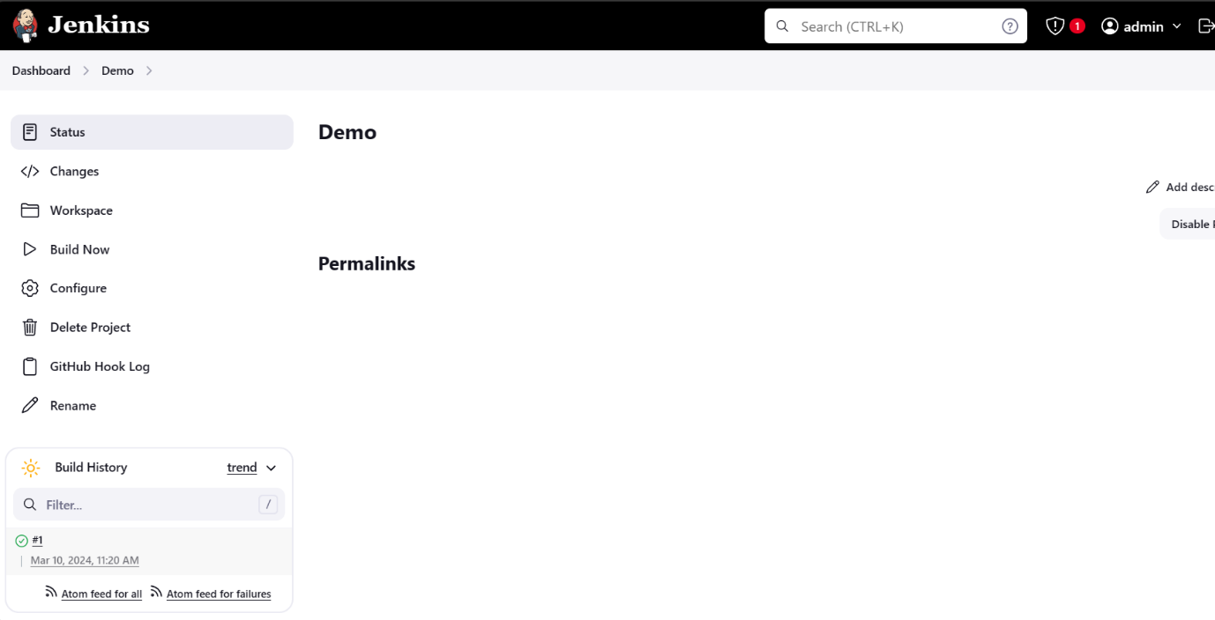

Open github and navigate to webhook. Create an webhook for repository.

The Jenkins is successfully integrated with github.

Go the code of the repo and add some changes into the files.

Do some changes in the ReadMe file and commit changes.

Navigate to Jenkins and we can see that new build is builded after making changes in the repository.

Part 2: Automation Testing using Selenium and Cypress.

1) Automation with Selenium.

* After installing selenium, write an script to execute automate the navigation to github.com and validate the title of the github website.

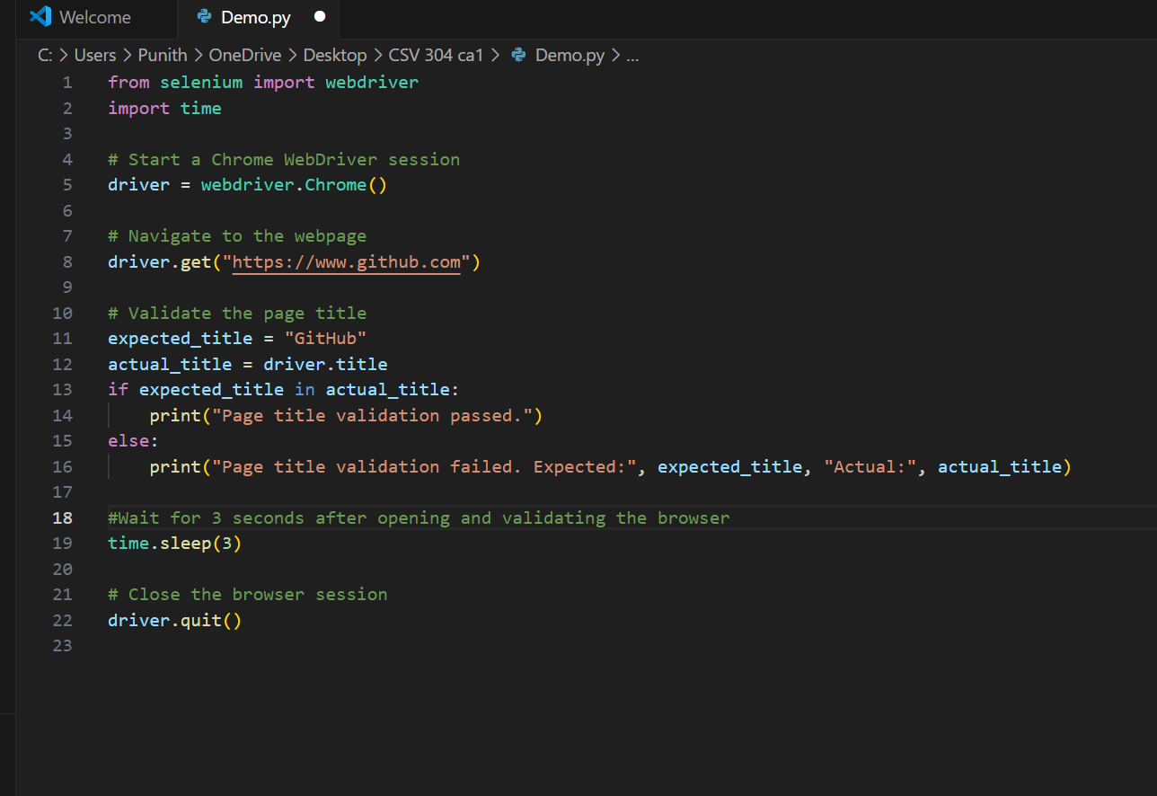

After successfully navigating to the browser, it closes after 3 seconds and validates the title of the page.

2) Automation with Cypress.

* Install node.js from the official download page of node.

Check th version by “node –version” and npm is the node package manager

Install cypress by the following command.

After installing , go to cypress folder and navigate to cypress>e2e and create a spec to automate a web browser test.

Open terminal and Enter “npx cypress open” to open gui of cypress.

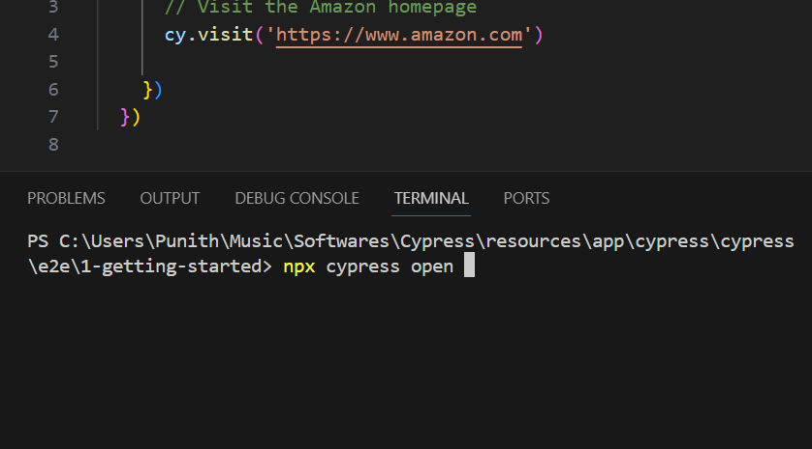

This is the dashboard of Cypress.

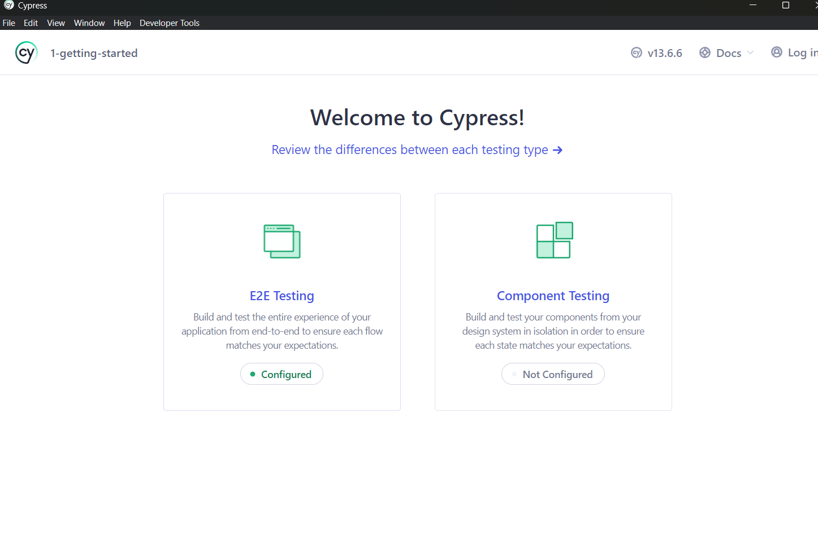

After selecting e2e testing, click on the spec file to run the automation test.

After executing successfully , the required web page gets opened in the selected browser.

